实验结果

任务描述：加入更多的变量x（周哲邮件定义），错开1年预测下一年的目标y（回归问题），并输出变量x的重要性排序。1）删除第22行华为数据，做5次交叉验证，输出回归的误差统计量。2）删除第22行华为的数据，并用第22行（黄凌燕补充后）华为的数据来做校验，输出回归的误差统计量。

误差统计量包括：1）回归的CDF曲线（越靠近左上角，回归精度越高）；2）平均误差、中值误差、最大误差、最小误差。

算法：1. Raondom Forest（RF）；2. Gradient Boosted Regression Tree（GBRT）

1. 5次交叉验证的结果（删除华为记录）

* 结论：不同Y目标特征排序略有不同。
* Y1 = Total Cash & ST Investments ($USDmm, Current rate)

Total Min: 0.322068

Total Mean: 1381.742906

Total Median: 298.335910

Total Max: 61716.848640

Feature importance:

Total Assets ($USDmm, Current rate): 0.034437

Cash from Ops. ($USDmm, Current rate): 0.034274

Net Income ($USDmm, Current rate): 0.033350

EBITDA ($USDmm, Current rate): 0.031705

Other Operating Exp. Total ($USDmm, Current rate): 0.030996

Cash from Ops./EBITDA % : 0.030932

Rev YOY % : 0.029974

Cash Acquisitions ($USDmm, Current rate): 0.029369

Net Income Margin % : 0.029366

Cash from Ops./Net Income% : 0.029190

Return on Equity % : 0.028454

Net Property, Plant & Equipment/ Total Assets % : 0.027958

Total Liabilities ($USDmm, Current rate): 0.027750

Cost Of Goods Sold ($USDmm, Current rate): 0.027548

Avg. Days Payable Out. (Days): 0.027525

Avg. Days Sales Out. (Days): 0.027364

Return on Assets % : 0.027179

R&D Exp. ($USDmm, Current rate): 0.027178

EBITDA Margin % : 0.026920

Depreciation & Amort., Total ($USDmm, Current rate): 0.026870

Capital Expenditure ($USDmm, Current rate): 0.026762

Total Asset Turnover : 0.026457

Total Debt/Equity % : 0.026314

Goodwill ($USDmm, Current rate): 0.025794

Total Liabilities/Total Assets % : 0.025603

Total Revenue ($USDmm, Current rate): 0.025516

Avg. Cash Conversion Cycle (Days): 0.024111

Net Property, Plant & Equipment ($USDmm, Current rate): 0.023421

Gross Margin % : 0.022413

Repurchase of Common Stock ($USDmm, Current rate): 0.021952

R&D Exp./Total Revenue % : 0.021602

Avg. Days Inventory Out. (Days): 0.021457

Goodwill/Total Revenue % : 0.021220

Payout Ratio (%): 0.021064

Cash Acquisitions/Total Revenue % : 0.019882

Number of Employees / Total Revenue [LTM] (Latest): 0.018106

Year Founded: 0.018105

Issuer Credit Rating - Foreign Currency LT [Latest] (Rating): 0.007997

准入资本市场难度: 0.003888

Industry Dummy: 0.003033

Development Phase : 0.002557

Share Bonus : 0.002335

Cash flow risk(0:low; 1: high): 0.002069

5次交叉验证的CDF曲线

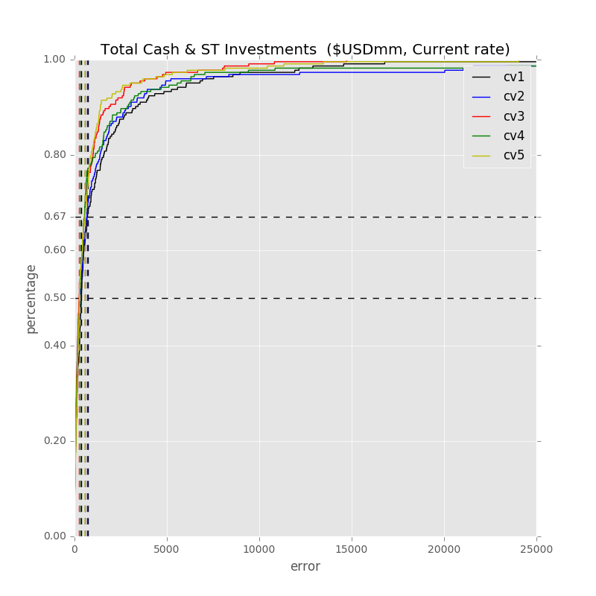

* Y2 = Total Cash & ST Investments/Total Revenue %

Total Min: 0.012101

Total Mean: 14.079719

Total Median: 6.006489

Total Max: 427.674043

Feature importance:

Rev YOY % : 0.036659

Net Income Margin % : 0.036579

Cash from Ops./Net Income% : 0.034345

Cash from Ops./EBITDA % : 0.033942

Net Property, Plant & Equipment/ Total Assets % : 0.032680

R&D Exp./Total Revenue % : 0.031918

Total Liabilities/Total Assets % : 0.031171

Avg. Cash Conversion Cycle (Days): 0.031084

Total Asset Turnover : 0.030749

Gross Margin % : 0.029794

Return on Assets % : 0.029142

EBITDA Margin % : 0.028812

Avg. Days Sales Out. (Days): 0.028577

Avg. Days Payable Out. (Days): 0.028509

Return on Equity % : 0.028495

Total Liabilities ($USDmm, Current rate): 0.028305

Total Assets ($USDmm, Current rate): 0.027566

Net Income ($USDmm, Current rate): 0.025971

Total Revenue ($USDmm, Current rate): 0.025488

Cost Of Goods Sold ($USDmm, Current rate): 0.025380

EBITDA ($USDmm, Current rate): 0.025116

Other Operating Exp. Total ($USDmm, Current rate): 0.024559

Total Debt/Equity % : 0.024139

Net Property, Plant & Equipment ($USDmm, Current rate): 0.024086

Cash from Ops. ($USDmm, Current rate): 0.023316

Repurchase of Common Stock ($USDmm, Current rate): 0.022931

Avg. Days Inventory Out. (Days): 0.022715

Goodwill ($USDmm, Current rate): 0.022243

Goodwill/Total Revenue % : 0.021738 (用good will/ total asset替代)

Capital Expenditure ($USDmm, Current rate): 0.021664

Cash Acquisitions ($USDmm, Current rate): 0.021636

Payout Ratio (%): 0.021324

Depreciation & Amort., Total ($USDmm, Current rate): 0.020932

R&D Exp. ($USDmm, Current rate): 0.020649

Cash Acquisitions/Total Revenue % : 0.019833

Year Founded: 0.017777

Number of Employees / Total Revenue [LTM] (Latest): 0.017714

Issuer Credit Rating - Foreign Currency LT [Latest] (Rating): 0.008653

准入资本市场难度: 0.003894

Development Phase : 0.003525

Industry Dummy: 0.003261

Share Bonus : 0.001713

Cash flow risk(0:low; 1: high): 0.001420 （用cash flow risk 的实际数值替代

5次交叉验证的CDF曲线

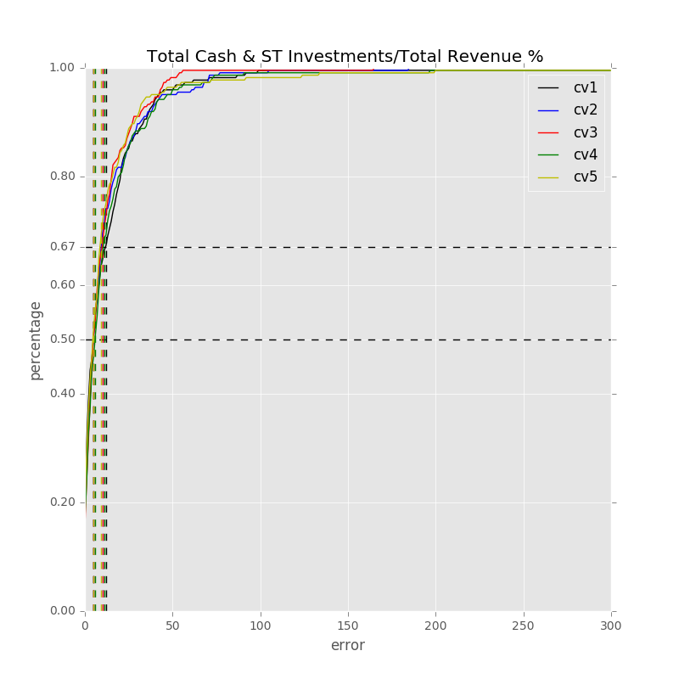

* Y3 = Total Cash & ST Investments/Avg. monthly cash outflow Month

Total Min: 0.001125

Total Mean: 2.168690

Total Median: 0.916181

Total Max: 36.564203

Feature importance:

Net Income Margin % : 0.038989

Rev YOY % : 0.036741

Cash from Ops./EBITDA % : 0.036268

Total Liabilities/Total Assets % : 0.033429

EBITDA Margin % : 0.031267

Avg. Cash Conversion Cycle (Days): 0.031206

Gross Margin % : 0.030549

Cash from Ops./Net Income% : 0.030412

Return on Assets % : 0.029934

Avg. Days Payable Out. (Days): 0.029489

Total Asset Turnover : 0.029299

Net Property, Plant & Equipment/ Total Assets % : 0.029270

Avg. Days Sales Out. (Days): 0.028600

Capital Expenditure ($USDmm, Current rate): 0.028573

Return on Equity % : 0.028067

R&D Exp./Total Revenue % : 0.027768

Cash from Ops. ($USDmm, Current rate): 0.026084

Net Income ($USDmm, Current rate): 0.026076

Total Revenue ($USDmm, Current rate): 0.025573

Total Assets ($USDmm, Current rate): 0.025454

Cost Of Goods Sold ($USDmm, Current rate): 0.025280

Repurchase of Common Stock ($USDmm, Current rate): 0.025268

Total Debt/Equity % : 0.024739

Total Liabilities ($USDmm, Current rate): 0.024377

Net Property, Plant & Equipment ($USDmm, Current rate): 0.023152

EBITDA ($USDmm, Current rate): 0.022738

Depreciation & Amort., Total ($USDmm, Current rate): 0.022722

Avg. Days Inventory Out. (Days): 0.022509

Cash Acquisitions/Total Revenue % : 0.022198

Goodwill/Total Revenue % : 0.022146 (用good will/ total asset替代)

Other Operating Exp. Total ($USDmm, Current rate): 0.021760

Cash Acquisitions ($USDmm, Current rate): 0.021222

Goodwill ($USDmm, Current rate): 0.021073

Payout Ratio (%): 0.019807

R&D Exp. ($USDmm, Current rate): 0.019653

Year Founded: 0.017798

Number of Employees / Total Revenue [LTM] (Latest): 0.017075

Issuer Credit Rating - Foreign Currency LT [Latest] (Rating): 0.007930

Industry Dummy: 0.004376

准入资本市场难度: 0.004153

Share Bonus : 0.002469

Development Phase : 0.002340

Cash flow risk(0:low; 1: high): 0.002168 （用cash flow risk 的实际数值替代

5次交叉验证的CDF曲线

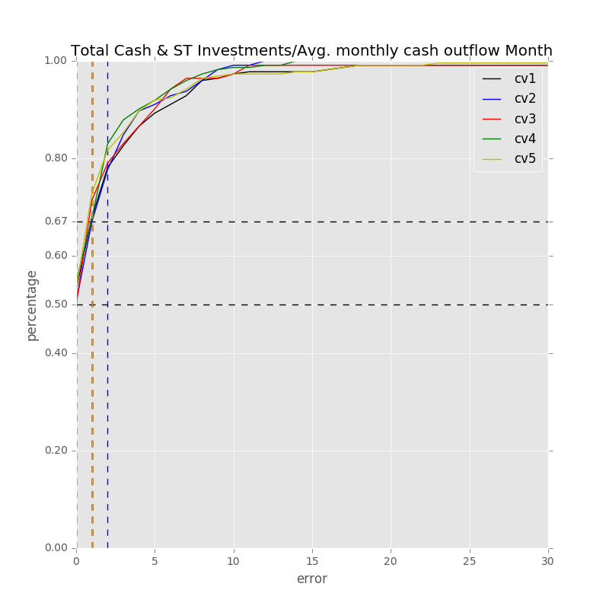

* Y4 = Total Cash & ST Investments-Debt ($USDmm, Current rate)

Total Min: 0.386258

Total Mean: 1225.176543

Total Median: 348.027008

Total Max: 51549.521136

Feature importance:

Net Income ($USDmm, Current rate): 0.032073

Rev YOY % : 0.031123

Total Liabilities ($USDmm, Current rate): 0.030891

Total Debt/Equity % : 0.030796

Net Property, Plant & Equipment/ Total Assets % : 0.030722

Total Liabilities/Total Assets % : 0.030719

Cash from Ops. ($USDmm, Current rate): 0.029673

Cash from Ops./Net Income% : 0.029636

Capital Expenditure ($USDmm, Current rate): 0.029633

Cash from Ops./EBITDA % : 0.029160

Total Asset Turnover : 0.028719

Other Operating Exp. Total ($USDmm, Current rate): 0.028593

Total Assets ($USDmm, Current rate): 0.027984

Cost Of Goods Sold ($USDmm, Current rate): 0.027910

EBITDA ($USDmm, Current rate): 0.027824

Avg. Days Sales Out. (Days): 0.027384

Total Revenue ($USDmm, Current rate): 0.027269

Avg. Days Payable Out. (Days): 0.026960

Return on Assets % : 0.026946

Net Property, Plant & Equipment ($USDmm, Current rate): 0.026743

Return on Equity % : 0.026660

Depreciation & Amort., Total ($USDmm, Current rate): 0.026473

Net Income Margin % : 0.026351

EBITDA Margin % : 0.026095

Avg. Cash Conversion Cycle (Days): 0.025934

Cash Acquisitions ($USDmm, Current rate): 0.025525

R&D Exp. ($USDmm, Current rate): 0.025326

Gross Margin % : 0.023555

Goodwill ($USDmm, Current rate): 0.023422

Avg. Days Inventory Out. (Days): 0.022986

Cash Acquisitions/Total Revenue % : 0.022476

Goodwill/Total Revenue % : 0.022348

Repurchase of Common Stock ($USDmm, Current rate): 0.021861

Payout Ratio (%): 0.021473

R&D Exp./Total Revenue % : 0.018134

Number of Employees / Total Revenue [LTM] (Latest): 0.018000

Year Founded: 0.016711

Issuer Credit Rating - Foreign Currency LT [Latest] (Rating): 0.011310

准入资本市场难度: 0.004726

Industry Dummy: 0.003240

Share Bonus : 0.002360

Development Phase : 0.002295

Cash flow risk(0:low; 1: high): 0.001979

5次交叉验证的CDF曲线

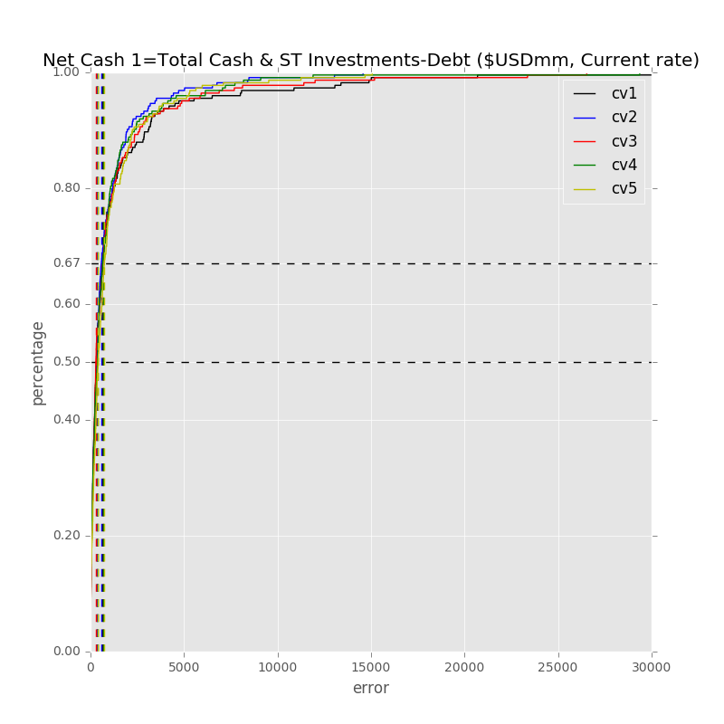

* Y5 = Total Cash & ST Investments/Total Assets %

Total Min: 0.009379

Total Mean: 7.203945

Total Median: 4.503365

Total Max: 74.531509

Feature importance:

Cash from Ops./EBITDA % : 0.034295

Cash from Ops./Net Income% : 0.033777

Total Liabilities/Total Assets % : 0.032871

Net Income Margin % : 0.031860

Rev YOY % : 0.031324

Return on Equity % : 0.030927

Total Asset Turnover : 0.030847

Avg. Cash Conversion Cycle (Days): 0.030328

Return on Assets % : 0.029518

Net Property, Plant & Equipment/ Total Assets % : 0.029319

Avg. Days Sales Out. (Days): 0.029263

EBITDA Margin % : 0.029043

Total Liabilities ($USDmm, Current rate): 0.028928

Depreciation & Amort., Total ($USDmm, Current rate): 0.028162

Avg. Days Payable Out. (Days): 0.027784

R&D Exp./Total Revenue % : 0.027679

Total Assets ($USDmm, Current rate): 0.027139

Gross Margin % : 0.026655

Other Operating Exp. Total ($USDmm, Current rate): 0.026613

Net Property, Plant & Equipment ($USDmm, Current rate): 0.025110

Total Revenue ($USDmm, Current rate): 0.024439

Net Income ($USDmm, Current rate): 0.024299

Cash from Ops. ($USDmm, Current rate): 0.024049

Total Debt/Equity % : 0.023673

EBITDA ($USDmm, Current rate): 0.023671

Capital Expenditure ($USDmm, Current rate): 0.023647

Avg. Days Inventory Out. (Days): 0.023475

R&D Exp. ($USDmm, Current rate): 0.023333

Number of Employees / Total Revenue [LTM] (Latest): 0.022795

Goodwill/Total Revenue % : 0.022655

Cost Of Goods Sold ($USDmm, Current rate): 0.022306

Year Founded: 0.022154

Repurchase of Common Stock ($USDmm, Current rate): 0.021809

Goodwill ($USDmm, Current rate): 0.021557

Cash Acquisitions ($USDmm, Current rate): 0.020581

Cash Acquisitions/Total Revenue % : 0.019838

Payout Ratio (%): 0.017503

Issuer Credit Rating - Foreign Currency LT [Latest] (Rating): 0.011334

准入资本市场难度: 0.005754

Industry Dummy: 0.003197

Development Phase : 0.003089

Cash flow risk(0:low; 1: high): 0.001766

Share Bonus : 0.001633

5次交叉验证的CDF曲线

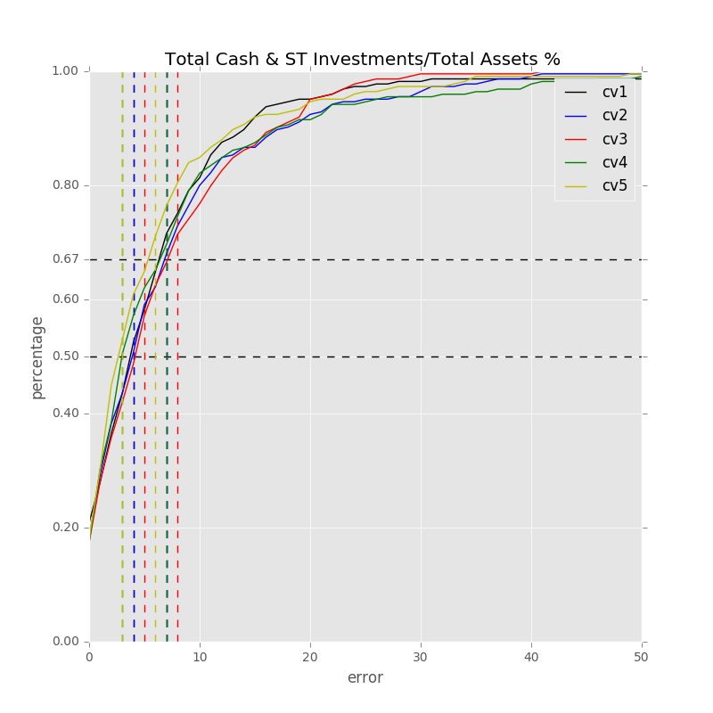

* Y6 = Net Cash Burn Ratio 1=Net Cash 1/ Avg. monthly cash outflow %

Total Min: 0.000732

Total Mean: 2.406650

Total Median: 1.145946

Total Max: 33.001589

Feature importance:

Cash from Ops./Net Income% : 0.038046

Total Liabilities/Total Assets % : 0.037015

Net Income Margin % : 0.036719

Rev YOY % : 0.035657

Avg. Days Sales Out. (Days): 0.033732

Cash from Ops./EBITDA % : 0.031751

Net Property, Plant & Equipment/ Total Assets % : 0.031708

Total Debt/Equity % : 0.030915

EBITDA Margin % : 0.030637

Gross Margin % : 0.030555

Total Asset Turnover : 0.029515

Total Liabilities ($USDmm, Current rate): 0.029439

Return on Assets % : 0.029005

Avg. Cash Conversion Cycle (Days): 0.028705

Other Operating Exp. Total ($USDmm, Current rate): 0.028357

Avg. Days Payable Out. (Days): 0.027599

Return on Equity % : 0.027156

Capital Expenditure ($USDmm, Current rate): 0.027025

Cost Of Goods Sold ($USDmm, Current rate): 0.026410

Cash from Ops. ($USDmm, Current rate): 0.025353

R&D Exp./Total Revenue % : 0.025190

Goodwill/Total Revenue % : 0.025099

Total Revenue ($USDmm, Current rate): 0.024962

Total Assets ($USDmm, Current rate): 0.024932

Net Property, Plant & Equipment ($USDmm, Current rate): 0.024881

Depreciation & Amort., Total ($USDmm, Current rate): 0.022901

Net Income ($USDmm, Current rate): 0.022666

EBITDA ($USDmm, Current rate): 0.022328

Avg. Days Inventory Out. (Days): 0.022017

Repurchase of Common Stock ($USDmm, Current rate): 0.021215

Cash Acquisitions ($USDmm, Current rate): 0.020698

Cash Acquisitions/Total Revenue % : 0.020095

Payout Ratio (%): 0.019057

Goodwill ($USDmm, Current rate): 0.019043

Number of Employees / Total Revenue [LTM] (Latest): 0.017459

R&D Exp. ($USDmm, Current rate): 0.016653

Year Founded: 0.015835

Issuer Credit Rating - Foreign Currency LT [Latest] (Rating): 0.007347

Development Phase : 0.003055

准入资本市场难度: 0.002995

Industry Dummy: 0.002898

Cash flow risk(0:low; 1: high): 0.001705

Share Bonus : 0.001672

5次交叉验证的CDF曲线

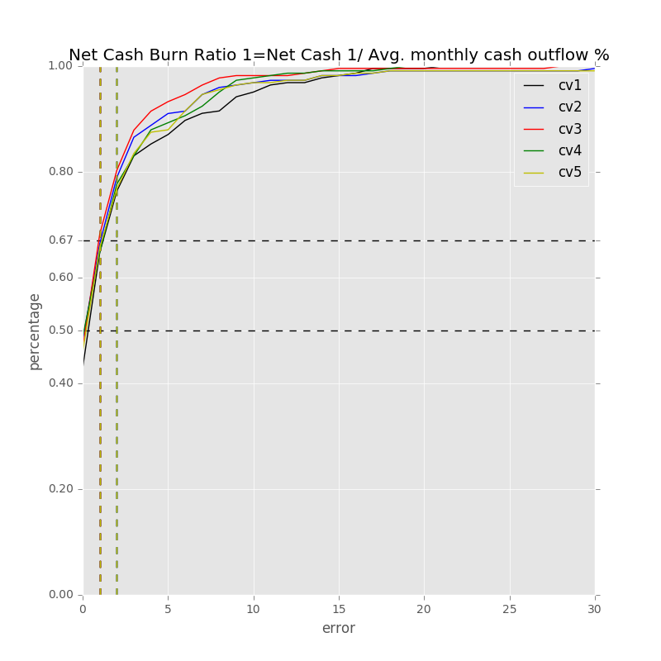

* Y7 = Net Cash 1/ Sales %

Total Min: 0.018517

Total Mean: 22.230835

Total Median: 8.191431

Total Max: 1512.189588

Feature importance:

Rev YOY % : 0.038722

Cash from Ops./Net Income% : 0.037052

Total Liabilities/Total Assets % : 0.036949

Net Income Margin % : 0.035627

Cash from Ops./EBITDA % : 0.033063

Net Property, Plant & Equipment/ Total Assets % : 0.032559

Return on Assets % : 0.031048

Avg. Days Sales Out. (Days): 0.030899

Total Debt/Equity % : 0.030564

Total Asset Turnover : 0.030253

Avg. Cash Conversion Cycle (Days): 0.029240

Total Revenue ($USDmm, Current rate): 0.029185

Other Operating Exp. Total ($USDmm, Current rate): 0.028574

Capital Expenditure ($USDmm, Current rate): 0.028234

EBITDA Margin % : 0.027632

Return on Equity % : 0.027112

Gross Margin % : 0.026282

Avg. Days Payable Out. (Days): 0.025476

Total Liabilities ($USDmm, Current rate): 0.025474

Total Assets ($USDmm, Current rate): 0.025293

R&D Exp./Total Revenue % : 0.024435

Net Property, Plant & Equipment ($USDmm, Current rate): 0.024020

EBITDA ($USDmm, Current rate): 0.023727

Goodwill/Total Revenue % : 0.023719

Net Income ($USDmm, Current rate): 0.023432

Repurchase of Common Stock ($USDmm, Current rate): 0.023338

Cash Acquisitions/Total Revenue % : 0.023179

Cash from Ops. ($USDmm, Current rate): 0.022883

Avg. Days Inventory Out. (Days): 0.022538

Cost Of Goods Sold ($USDmm, Current rate): 0.021848

Depreciation & Amort., Total ($USDmm, Current rate): 0.021785

Cash Acquisitions ($USDmm, Current rate): 0.019966

Number of Employees / Total Revenue [LTM] (Latest): 0.019869

Goodwill ($USDmm, Current rate): 0.019502

R&D Exp. ($USDmm, Current rate): 0.019128

Year Founded: 0.017301

Payout Ratio (%): 0.017214

Issuer Credit Rating - Foreign Currency LT [Latest] (Rating): 0.007878

准入资本市场难度: 0.003803

Industry Dummy: 0.003582

Development Phase : 0.003501

Share Bonus : 0.002403

Cash flow risk(0:low; 1: high): 0.001708

5次交叉验证的CDF曲线

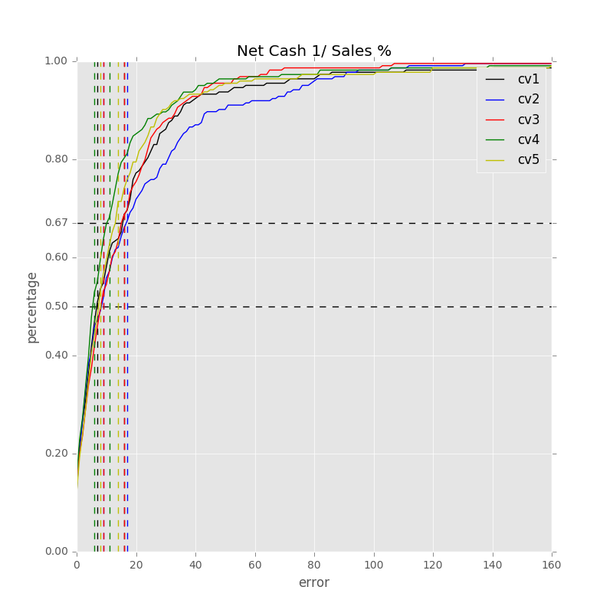

1. 预测华为数据的结果

（训练数据已排除华为）

* Y1 = Total Cash & ST Investments ($USDmm, Current rate)

Min Error: 28.078976

Mean Error: 2737.568674

Median Error: 855.950024

Max Error: 20576.053283

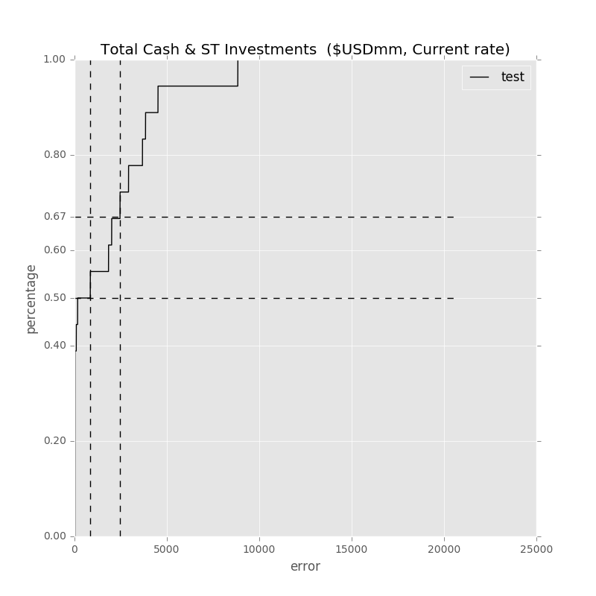

* Y2 = Total Cash & ST Investments/Total Revenue %

Min Error: 0.787446

Mean Error: 6.953818

Median Error: 4.372036

Max Error: 41.739226

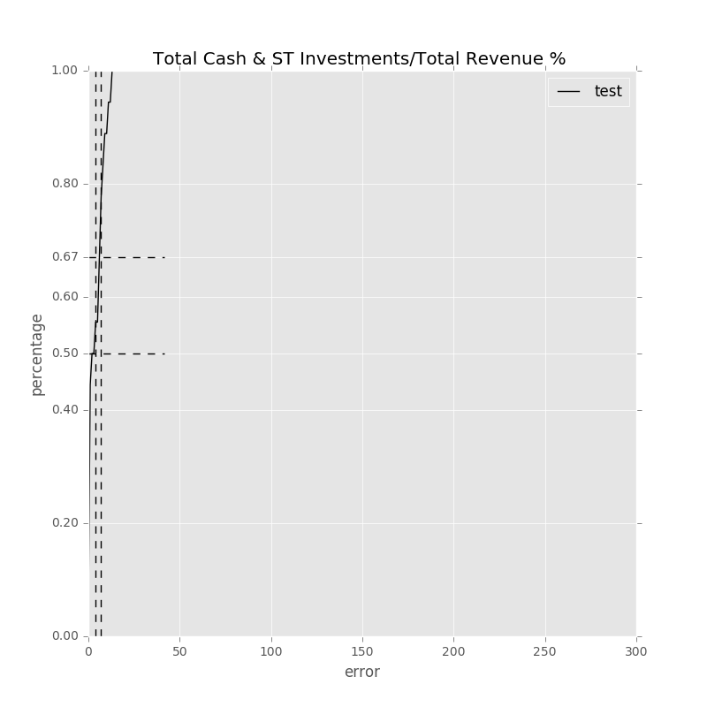

* Y3 = Total Cash & ST Investments/Avg. monthly cash outflow Month

Min Error: 0.050539

Mean Error: 1.001787

Median Error: 0.260419

Max Error: 6.823539

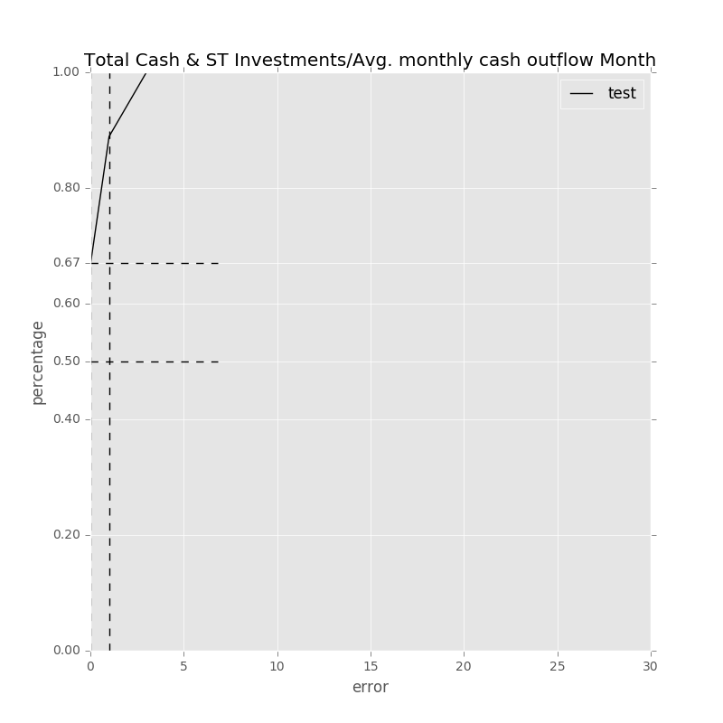

* Y4 = Total Cash & ST Investments-Debt ($USDmm, Current rate)

Min Error: 32.115878

Mean Error: 2739.121628

Median Error: 363.392985

Max Error: 12092.178100

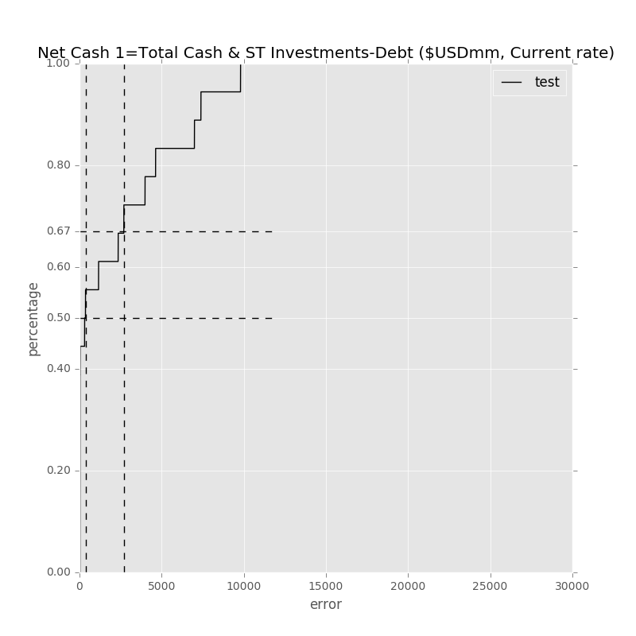

* Y5 = Total Cash & ST Investments/Total Assets %

Min Error: 0.549067

Mean Error: 4.779283

Median Error: 0.658980

Max Error: 34.958458

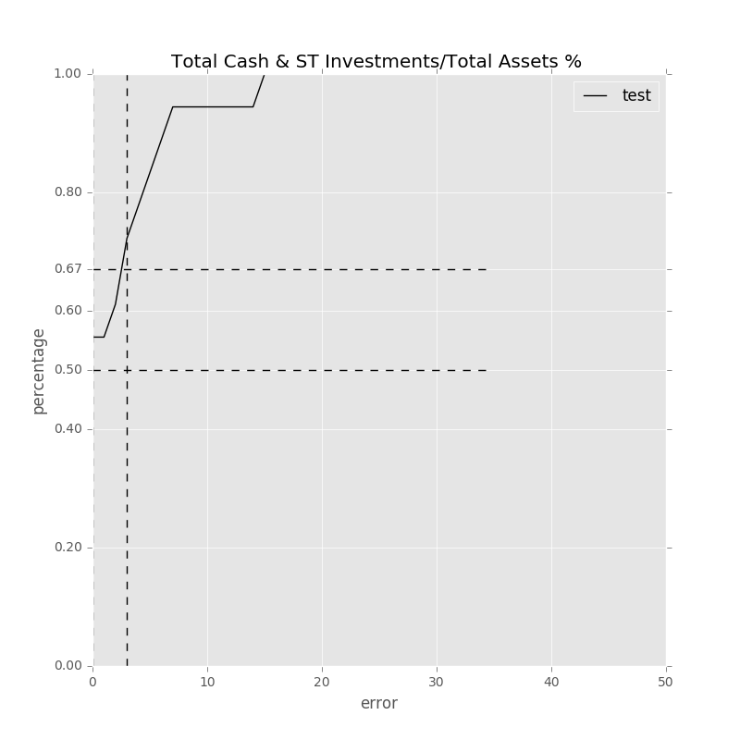

* Y6 = Net Cash Burn Ratio 1=Net Cash 1/ Avg. monthly cash outflow %

Min Error: 0.066206

Mean Error: 1.066923

Median Error: 0.839759

Max Error: 3.957758

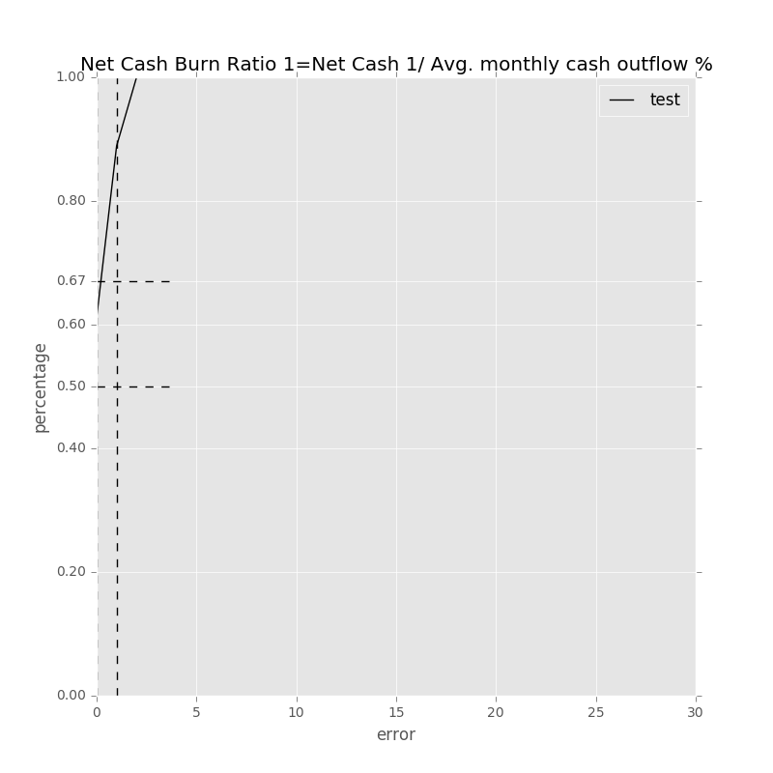

* Y7 = Net Cash 1/ Sales %

Min Error: 0.819750

Mean Error: 6.660020

Median Error: 2.595256

Max Error: 26.813208

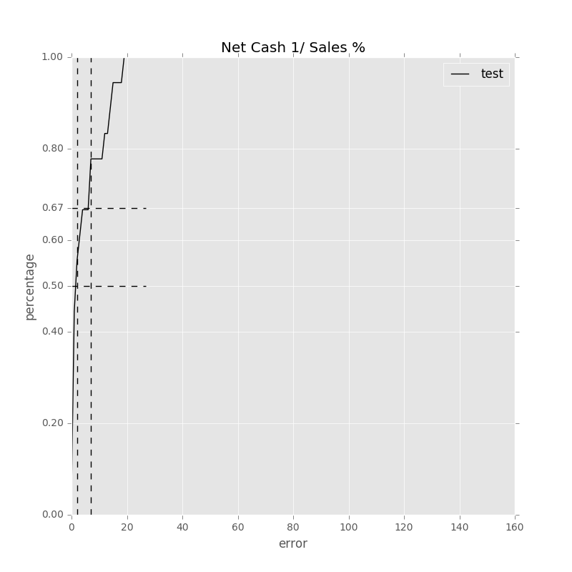

1. 按行业划分三个子群的分析（Semiconductors and Semiconductor Equipment；Software and Services；Technology Hardware and Equipment）

\*删除华为的数据

\*5次交叉验证

\*仅分析烧钱率Y3 = Total Cash & ST Investments/Avg. monthly cash outflow Month

* Semiconductors and Semiconductor Equipment（418样本）：

Total Min: 0.001790

Total Mean: 3.674627

Total Median: 2.413102

Total Max: 23.998869

Feature importance:

Rev YOY % : 0.024612

Net Income Margin % : 0.023990

Net Property, Plant & Equipment/ Total Assets % : 0.021644

Cash from Ops./EBITDA % : 0.021277

Total Liabilities/Total Assets % : 0.021119

Cash from Ops./Net Income% : 0.020997

Return on Equity % : 0.020711

Capital Expenditure ($USDmm, Current rate): 0.020040

Avg. Days Payable Out. (Days): 0.020030

Return on Assets % : 0.019991

Total Asset Turnover : 0.019791

Gross Margin % : 0.019415

EBITDA Margin % : 0.019409

Avg. Cash Conversion Cycle (Days): 0.019122

Avg. Days Inventory Out. (Days): 0.018985

Other Operating Exp. Total ($USDmm, Current rate): 0.017717

Total Debt/Equity % : 0.017190

R&D Exp./Total Revenue % : 0.017032

Cash from Ops. ($USDmm, Current rate): 0.016745

Repurchase of Common Stock ($USDmm, Current rate): 0.016626

Total Liabilities ($USDmm, Current rate): 0.016350

Avg. Days Sales Out. (Days): 0.015459

Depreciation & Amort., Total ($USDmm, Current rate): 0.015373

Total Assets ($USDmm, Current rate): 0.014958

Net Income ($USDmm, Current rate): 0.014696

Total Revenue ($USDmm, Current rate): 0.014527

Number of Employees / Total Revenue [LTM] (Latest): 0.014501

Net Property, Plant & Equipment ($USDmm, Current rate): 0.014076

R&D Exp. ($USDmm, Current rate): 0.013713

Cost Of Goods Sold ($USDmm, Current rate): 0.012843

EBITDA ($USDmm, Current rate): 0.012597

Goodwill/Total Revenue % : 0.012416

Payout Ratio (%): 0.011239

Year Founded: 0.009793

Cash Acquisitions ($USDmm, Current rate): 0.009353

Goodwill ($USDmm, Current rate): 0.009107

Cash Acquisitions/Total Revenue % : 0.008690

Issuer Credit Rating - Foreign Currency LT [Latest] (Rating): 0.004930

准入资本市场难度: 0.003197

Development Phase : 0.003148

Share Bonus : 0.001092

Cash flow risk(0:low; 1: high): 0.000500

Industry Dummy: 0.000000

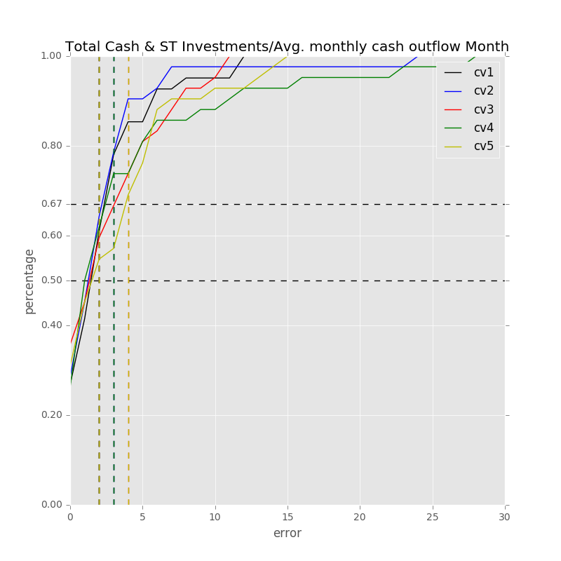

* Software and Services（873样本）

Total Min: 0.000157

Total Mean: 2.732903

Total Median: 1.272639

Total Max: 28.456467

Feature importance:

Rev YOY % : 0.042956

Net Income Margin % : 0.037698

EBITDA Margin % : 0.035142

Avg. Days Sales Out. (Days): 0.033941

Cash from Ops./EBITDA % : 0.032753

Total Liabilities/Total Assets % : 0.032613

Cash from Ops./Net Income% : 0.031387

Depreciation & Amort., Total ($USDmm, Current rate): 0.029678

Return on Assets % : 0.029018

Other Operating Exp. Total ($USDmm, Current rate): 0.028431

Number of Employees / Total Revenue [LTM] (Latest): 0.027838

Total Revenue ($USDmm, Current rate): 0.027667

Capital Expenditure ($USDmm, Current rate): 0.026696

Cash Acquisitions/Total Revenue % : 0.026695

Gross Margin % : 0.026610

EBITDA ($USDmm, Current rate): 0.026389

Cash Acquisitions ($USDmm, Current rate): 0.025648

Avg. Cash Conversion Cycle (Days): 0.025500

Net Property, Plant & Equipment ($USDmm, Current rate): 0.025416

Return on Equity % : 0.025346

Cash from Ops. ($USDmm, Current rate): 0.025283

Total Assets ($USDmm, Current rate): 0.025255

Cost Of Goods Sold ($USDmm, Current rate): 0.025093

Year Founded: 0.024559

Repurchase of Common Stock ($USDmm, Current rate): 0.024391

Total Asset Turnover : 0.024178

Net Income ($USDmm, Current rate): 0.024163

Avg. Days Payable Out. (Days): 0.023921

Total Liabilities ($USDmm, Current rate): 0.023840

Total Debt/Equity % : 0.023227

Net Property, Plant & Equipment/ Total Assets % : 0.023080

Goodwill/Total Revenue % : 0.021304

R&D Exp./Total Revenue % : 0.020865

Goodwill ($USDmm, Current rate): 0.020313

R&D Exp. ($USDmm, Current rate): 0.018004

Payout Ratio (%): 0.015726

Avg. Days Inventory Out. (Days): 0.014474

Issuer Credit Rating - Foreign Currency LT [Latest] (Rating): 0.009748

准入资本市场难度: 0.005942

Development Phase : 0.003436

Share Bonus : 0.003144

Cash flow risk(0:low; 1: high): 0.002633

Industry Dummy: 0.000000

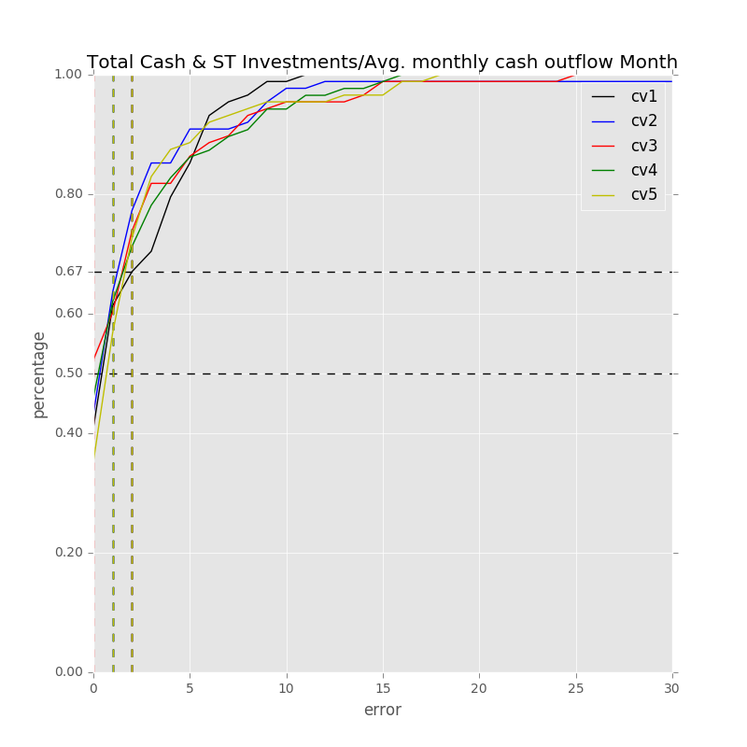

* Technology Hardware and Equipment：

Total Min: 0.000062

Total Mean: 1.035795

Total Median: 0.531571

Total Max: 9.180102

Feature importance:

Rev YOY % : 0.037058

Cash from Ops./EBITDA % : 0.033285

Cash from Ops./Net Income% : 0.032911

Avg. Days Sales Out. (Days): 0.032659

Avg. Days Payable Out. (Days): 0.032551

Total Liabilities/Total Assets % : 0.032071

Net Property, Plant & Equipment/ Total Assets % : 0.031611

Gross Margin % : 0.031344

Avg. Days Inventory Out. (Days): 0.030572

Total Asset Turnover : 0.030270

Avg. Cash Conversion Cycle (Days): 0.029948

Total Debt/Equity % : 0.029839

Total Liabilities ($USDmm, Current rate): 0.029245

Cost Of Goods Sold ($USDmm, Current rate): 0.029065

Other Operating Exp. Total ($USDmm, Current rate): 0.028977

Net Income Margin % : 0.028925

Return on Assets % : 0.027881

Capital Expenditure ($USDmm, Current rate): 0.026973

Return on Equity % : 0.026973

Total Assets ($USDmm, Current rate): 0.026728

Total Revenue ($USDmm, Current rate): 0.026382

Net Income ($USDmm, Current rate): 0.026136

EBITDA ($USDmm, Current rate): 0.026123

EBITDA Margin % : 0.025704

Depreciation & Amort., Total ($USDmm, Current rate): 0.025496

R&D Exp./Total Revenue % : 0.024146

Payout Ratio (%): 0.023135

Cash from Ops. ($USDmm, Current rate): 0.022855

Net Property, Plant & Equipment ($USDmm, Current rate): 0.022456

Cash Acquisitions/Total Revenue % : 0.021871

Goodwill ($USDmm, Current rate): 0.021126

Goodwill/Total Revenue % : 0.019657

Cash Acquisitions ($USDmm, Current rate): 0.019338

Repurchase of Common Stock ($USDmm, Current rate): 0.018765

R&D Exp. ($USDmm, Current rate): 0.018194

Number of Employees / Total Revenue [LTM] (Latest): 0.017749

Year Founded: 0.016409

Issuer Credit Rating - Foreign Currency LT [Latest] (Rating): 0.005771

Development Phase : 0.003893

准入资本市场难度: 0.003172

Cash flow risk(0:low; 1: high): 0.001480

Share Bonus : 0.001256

Industry Dummy: 0.000000